Sign-up Form Testing:
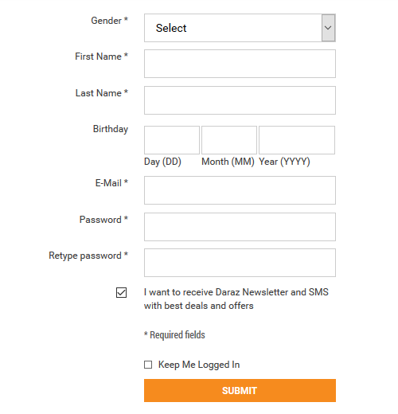
Unit Level Test Cases:
Rules:
- First Name must be alphabets only
- Last Name must be alphabets only
- Email format must be correct
- Password must be at least 8 characters long, it must have alphabets, numbers and special characters
- Password and Retype Password must be same
- Gender must be selected
- Birthday format must be like DD-MM-YYYY

- First Name: V.1.0
Test Data | Expected Result | Actual Result | Pass/Fail
Ali*123 | Should be rejected | Has been accepted | Fail
M Ali | Should be accepted | Has been accepted | Pass
Ali | Should be accepted | Has been accepted | Pass
123456 | Should be rejected | Has been rejected | Pass
@#$%^ | Should be rejected | Has been accepted | Fail

First Name: V.1.1
Test Data | Expected Result | Actual Result | Pass/Fail
Ali*123 | Should be rejected | Has been accepted | Fail
M Ali | Should be accepted | Has been accepted | Pass
Ali | Should be accepted | Has been accepted | Pass
123456 | Should be rejected | Has been rejected | Pass
@#$%^ | Should be rejected | Has been accepted | Pass

First Name: V.1.2
Test Data | Expected Result | Actual Result | Pass/Fail
Ali*123 | Should be rejected | Has been accepted | Pass
M Ali | Should be accepted | Has been accepted | Pass
Ali | Should be accepted | Has been accepted | Pass
123456 | Should be rejected | Has been rejected | Pass
@#$%^ | Should be rejected | Has been accepted | Pass

- Email: V.1.0
Test Data | Expected Result | Actual Result | Pass/Fail
Zeeshan@gmail.com | Should be accepted | Has been accepted | Pass
@zeeshangmail.com | Should be rejected | Has been rejected | Pass
Zeeshangamil.com@ | Should be rejected | Has been rejected | Pass
zeeshan@.com | Should be rejected | Has been rejected | Pass
zeeshan@.pk.uet | Should be rejected | Has been rejected | Pass
.comzeeshan@gmail | Should be rejected | Has been rejected | Pass
Zeeshan.com@gmail | Should be rejected | Has been rejected | Pass

- Password: V.1.0
Test Data | Expected Result | Actual Result | Pass/Fail
Ali@1234 | Should be accepted | Has been accepted | Pass

- Retype Password: V.1.0
Test Data | Expected Result | Actual Result | Pass/Fail
User will enter password in the Retype Password Field. | Password entered in the Retype Password should be same as the password entered in the Password field. | Password entered in the Retype Password is same as the password entered in the Password field. | Pass

Sign-In form Testing:
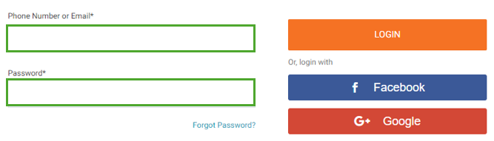
Forgot Password: V.1.0
Test Data | Expected Result | Actual Result | Pass/Fail
User will click the forgot password button | Page should be jumped to forgot password page | Page has been jumped to forgot password page | Pass

Facebook Login Button: V.1.0
Test Data | Expected Result | Actual Result | Pass/Fail
User will click the facebook login button | Page should be jumped to login through facebook option page | Page has not been jumped to login through facebook option page | Fail

Facebook Login Button: V.1.1
Test Data | Expected Result | Actual Result | Pass/Fail
User will click the facebook login button | Page should be jumped to login through facebook option page | Page has not been jumped to login through facebook option page | Pass

